To establish learning ambience for ushering in computer engineering professionals in core and multidisciplinary area by developing Problemsolving skills through emerging technologies.

Session | 2025-26 (ODD) | Course Name | Operating System Lab
Semester | 5 | Course Code | 23IOT1504
Roll No | 37 | Name of Student | Dhanashri Raut

Practical Number | 5
Course Outcome | - Understand Computer System Configuration and Simulate system resources efficiently using Linux Commands (CO1)  - Analyse operating system functionalities utilizing system calls, thread programming and process scheduling algorithms (CO2)  - Apply Synchronization primitives to implement a Deadlock-free solution(CO3)  - Simulate Disk scheduling, Memory allocation, File allocation, page replacement algorithms (CO4)
Aim | Simulate Banker’s Deadlock Detection Algorithm.
Problem Definition | To simulate the Banker’s Deadlock Detection Algorithm in C language.  The program should accept resource allocation, request, and availability matrices for multiple processes and determine whether the system is in a safe state or deadlock state.
Theory | The Banker’s Algorithm is used in operating systems to avoid or detect deadlocks by ensuring resource allocation does not lead to an unsafe state.  It works by simulating resource allocation for each process and checking whether all processes can eventually complete their execution without getting stuck waiting for resources indefinitely.  Key Concepts:  - Available: Resources currently available in the system.  - Allocation: Resources currently allocated to each process.  - Request (Need): Remaining resources each process needs to complete execution.  - Finish: Boolean flag indicating if a process has completed.
To establish learning ambience for ushering in computer engineering professionals in core and multidisciplinary area by developing Problemsolving skills through emerging technologies.

Steps of Deadlock Detection:
- Initialize Work = Available and Finish[i] = false for all processes.
- Find a process whose Request ≤ Work and Finish[i] = false.
- If found, allocate resources to it:
Work = Work + Allocation[i] and Finish[i] = true.
- Repeat until no such process exists.
- If all processes are marked Finish = true → No Deadlock.
Otherwise → Deadlock detected.
Give Procedure and Execution  (100 Words) | - Input number of processes and resource types.  - Enter Allocation, Request (Need), and Available matrices.  - Initialize Finish[i] = false and Work = Available.  - Search for a process whose request ≤ Work and not yet finished.  - If found, mark it finished and update Work = Work + Allocation[i].  - Repeat until all processes are finished or no progress can be made.  - If all processes finish, system is in safe state; otherwise, a deadlock exists.
Give Procedure and Execution  (100 Words) | Code:  #include <stdio.h> int main() {  int n, m, i, j, k;  int alloc[10][10], req[10][10], avail[10]; int finish[10], work[10], deadlock = 0;  printf("Enter number of processes: "); scanf("%d", &n); printf("Enter number of resource types: "); scanf("%d", &m);  printf("Enter Allocation Matrix:\n");  for (i = 0; i < n; i++) for (j = 0; j < m; j++)  scanf("%d", &alloc[i][j]);  printf("Enter Request Matrix:\n");
To establish learning ambience for ushering in computer engineering professionals in core and multidisciplinary area by developing Problemsolving skills through emerging technologies.

for (i = 0; i < n; i++) for (j = 0; j < m; j++)
scanf("%d", &req[i][j]);

printf("Enter Available Resources:\n");
for (i = 0; i < m; i++)
scanf("%d", &avail[i]);

for (i = 0; i < m; i++) work[i] = avail[i]; for (i = 0; i < n; i++) finish[i] = 0;

int count = 0; while (count < n) { int found = 0; for (i = 0; i < n; i++) { if (!finish[i]) { int flag = 0; for (j = 0; j < m; j++) { if (req[i][j] > work[j]) {
flag = 1; break;
} }
if (flag == 0) { for (k = 0; k < m; k++) work[k] += alloc[i][k];
finish[i] = 1; found = 1; count++; printf("Process P%d executed successfully.\n", i);
}
} }
if (!found) { break;
}
}

for (i = 0; i < n; i++) { if (!finish[i]) { deadlock = 1; break;
To establish learning ambience for ushering in computer engineering professionals in core and multidisciplinary area by developing Problemsolving skills through emerging technologies.

}
}

if (deadlock) printf("\nSystem is in DEADLOCK state.\n"); else printf("\nSystem is in SAFE state.\n");

return 0;
}
Output:
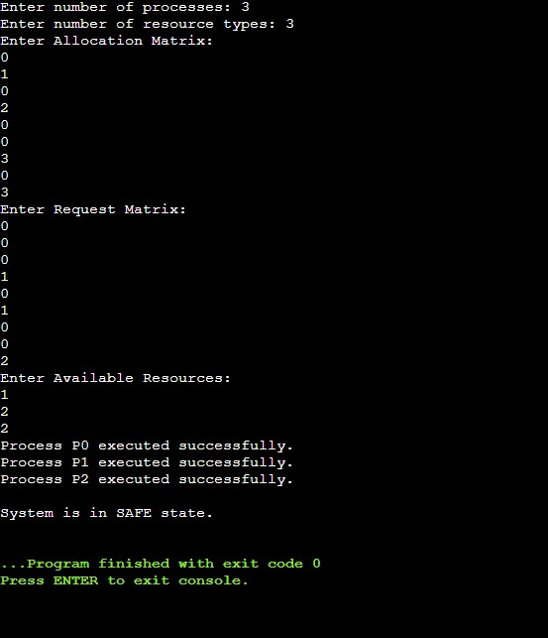

To establish learning ambience for ushering in computer engineering professionals in core and multidisciplinary area by developing Problemsolving skills through emerging technologies.

Output Analysis | The algorithm simulates the allocation and checks if each process can complete with currently available resources. All processes were able to complete without waiting indefinitely, indicating that the system is in a safe state.  If any process remains unfinished, it implies a deadlock. Thus, the algorithm efficiently detects unsafe or deadlock conditions in resource allocation systems.
Link of student Github profile where lab assignment has been uploaded | https://github.com/24030192-lab/-OS-Practicals
Conclusion | Successfully simulated Banker’s Deadlock Detection Algorithm.  The program correctly detects whether the system is in a safe or deadlock state based on current allocations and resource requests.
Plag Report  (Similarity index <  12%) | 
Date | 29/09/25

